
Trendzo

INVESTOR BRIEF
Try before you pay — fashion, delivered in an hour.
Pre-seed round · Launch city: Indore, India

PREPARED FOR Prospective investors — pre-seed
PREPARED BY Trendzo Founding Team
DATE June 2026 VERSION 1.0
CONTACT Akshat Jain, Founder & CEO · founders@trendzo.in · +91 00000 00000
Strictly private & confidential. Prepared for the named recipient only — not for distribution or onward circulation.

Contents

1 Executive Summary 1
2 The Problem 1
3 The Solution 2
4 Market Opportunity 3
5 Traction & Validation 4
6 Business Model & Unit Economics 5
7 Competitive Landscape 7
8 Team 7
9 Financial Projections 9
10 The Ask 11
A Appendix — Model, Assumptions & Sensitivities 13
All figures in Indian rupees. The full five-year model, driver log, sensitivities, and market-sizing sources are in the Appendix.

1 Executive Summary
Trendzo is building the one part of fashion retail quick-commerce never solved: letting shoppers try clothes on before they pay, delivered in an hour.
Trendzo is a one-hour fashion-delivery marketplace for India where the delivery agent waits at the door while the shopper tries each item on — they keep what fits and hand back the rest, paying only for what they keep. The company holds no inventory: it lists the live stock of local clothing stores and routes each order to the nearest one that has the item.
The problem is structural. Online fashion forces shoppers to pay upfront and gamble on fit, which drives industry returns of 30–40% and suppresses trial — and quick-commerce, built around grocery dark stores, was never engineered for apparel. Trendzo’s answer is Try-and-Buy at the door: an asset-light model that turns the delivery moment into the fitting room.
The strongest proof is the economics. A reconciled, bottom-up five-year model shows contribution per order climbing from roughly breakeven in Year 1 to ₹95 by Year 5, EBITDA breakeven in Year 4, and an 18% EBITDA margin at scale — reached on a peak cash need of only ₹2.18 crore.
We are raising a ₹2 crore pre-seed to launch Indore, build the retailer and agent platform, and prove the unit economics in one city — funding the path to a Year-4 breakeven on under ₹3 crore of total capital.

₹700  Launch AOV | 3.7×  LTV : CAC (mature) | ₹20.7 Cr  Year-5 net revenue | ₹2 Cr  Pre-seed ask

What it means. Every figure here is substantiated downstream — the market in §4, the economics in §6, the projections in §9, the ask in §10. The thesis is one line: solve fit, and you unlock conversion, kill returns, and bring local fashion online.

2 The Problem
India’s fashion market is enormous and digitizing fast — but online apparel is broken in three specific ways quick-commerce has not fixed.
India’s fashion and apparel retail market is roughly ₹9.6 lakh crore, and shifting online quickly. Yet the online experience remains structurally flawed, and the flaws share one root cause: the purchase is divorced from the physical try-on. Three distinct failures follow.

Failure 1 — Fit uncertainty drives returns
The failure: shoppers buy blind, so 30–40% of fashion orders come back. Why it persists: no online channel lets you confirm fit before paying. What it costs: retailers lose margin to reverse logistics, restocking and write-downs; platforms lose cash to refunds and stranded units.

Failure 2 — Paying first suppresses trial
The failure: committing money before seeing the product on your body kills conversion, especially for first-time shoppers. Why it persists: payment is decoupled from delivery in every mainstream model. What it costs: conversion at the top of the funnel, and an inflated cost of acquisition.

Failure 3 — Local stores are invisible online
The failure: thousands of city fashion stores hold relevant stock but have no digital storefront and no fast last-mile. Why it persists: building technology and logistics is far beyond a single store. What it costs: stores forgo demand they could serve, and shoppers are left with slow, distant or out-of-stock options.
What it means. These are not three problems but one seen three ways — the buy is separated from the try. Each maps directly onto a Trendzo capability in the next section; we raise no problem the product does not later answer.

3 The Solution
Trendzo rebuilds the fashion purchase around the try-on, with three mechanisms that map one-to-one onto the three failures above.

Try-and-Buy at the door — the differentiator (answers Failures 1 & 2)
How it works: the shopper orders and prepays; an agent brings the items in a plain bag and waits up to 30 minutes; the shopper tries each piece on and says keep or return; the agent inspects and records every return on the spot, and only the kept items stay charged — returns are refunded once the store verifies them. Because fit is confirmed before the money is final, returns collapse and the pay-first friction disappears.

One-hour delivery from local stores — asset-light (answers Failure 3)
How it works: Trendzo carries no inventory. It lists local stores’ live stock — kept current by an integrated billing/POS sync that also captures their walk-in sales — routes each order to the nearest store holding the item, and delivers in about 60 minutes through an in-house fleet. The result is quick-commerce speed on stores’ existing shelves: no warehouses, no inventory risk, no dead stock on Trendzo’s books.

A full retailer operating system (answers Failure 3)
How it works: a web dashboard and a dedicated agent app give a store order management, inventory sync, returns handling, payouts and analytics, while Trendzo’s admin centrally runs discounts, disputes and moderation. Any local fashion store goes online and same-hour without building a single piece of software itself.
Two browsing layers sit on top: an on-screen virtual try-on that previews a garment on the shopper’s photo, and a shoppable reel feed for discovery — both funnel into the same one-hour, try-at-the-door fulfilment.
What it means. One mechanism — the try-on at the door — resolves all three failures at once, and the asset-light store model is what lets it scale city by city. We ask the reader to believe a mechanic, not a slogan.

4 Market Opportunity
Trendzo plays in a very large, fast-digitizing market and needs only a sliver of it — so the risk lives in execution, not in market size.
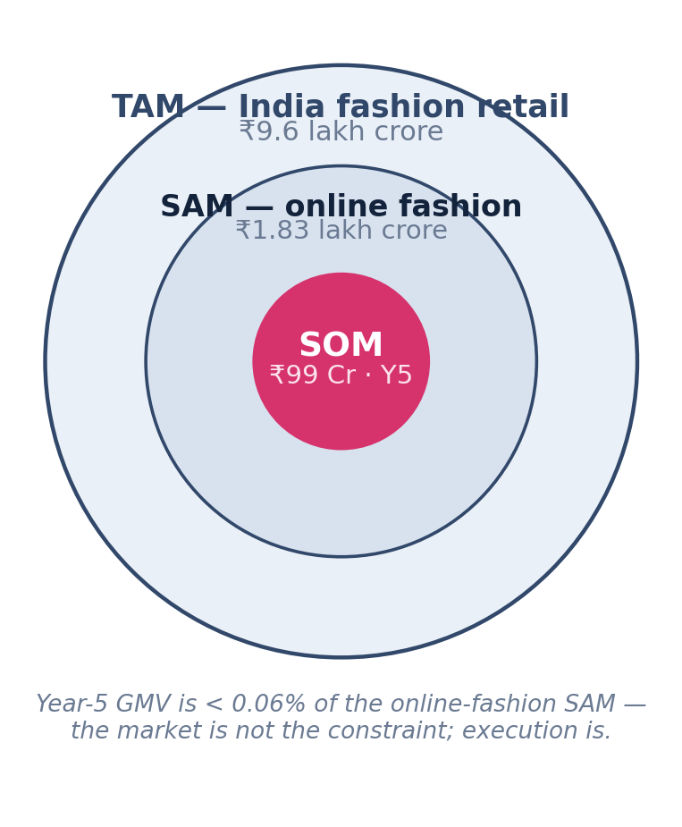
Figure 1 — Market sizing: TAM / SAM / SOM, with methodology below.
TAM (top-down). India’s total fashion and apparel retail is ~₹9.6 lakh crore, measured as total category retail spend.
SAM (top-down). Online fashion in India is ~₹1.83 lakh crore. The bridge from TAM: Trendzo is a digital channel, so only the online-addressable share is serviceable — concentrated further in the metro and tier-1 catchments where one-hour delivery is feasible.
SOM (bottom-up). Year-5 GMV of ₹99 crore, built from the ground up: 11 cities × ~100 stores each × modelled order density × ₹700–900 average order value. That obtainable slice is under 0.06% of the online-fashion SAM.
That bottom-up number is a plan, not an aspiration. Indore launches first in Year 1 (~100 stores, a three-agent fleet), then 2 → 4 → 7 → 11 cities across five years, each city adding local onboarding and a small fleet. A quick-commerce tailwind sits underneath: India quick-commerce GMV is ~₹0.6 lakh crore (FY25), projected at ~₹2.9 lakh crore by 2030, with apparel the next category to be unbundled.
What it means. Because the obtainable market is set by how fast we onboard stores and fill fleet capacity — not by demand that may never exist — top-of-funnel risk is small. The constraint, and the rest of this brief, is execution and density.

5 Traction & Validation
Trendzo is pre-launch, and de-risked across the three things that usually sink a pre-seed company: product, operations, and economics.

1  Consumer app built | 5  Operating SOPs complete | ~100  Indore stores targeted | Year 2  Contribution-positive*

The model assumes this target conversion, benchmarked to quick-commerce norms — shown so it can be tested against live data once Indore launches:
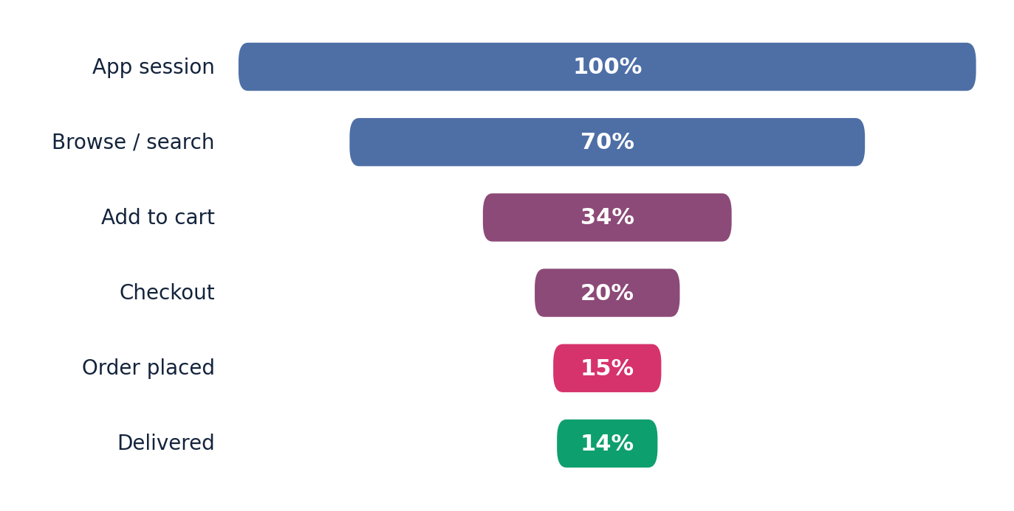
Figure 2 — Target conversion funnel (model basis; pre-launch, not yet realised).
Product is built, not promised. The consumer app — browse, cart, all four delivery modes, virtual try-on, wallet, returns — is implemented; the retailer/admin dashboard and agent app are fully specified and in build. Against the pre-seed norm of a slide deck, a working app plus a complete operating spec is the benchmark — and it materially lowers execution risk.
The operating model is documented end-to-end. Five reconciled playbooks — delivery & fleet, returns & held-items, commission & payouts, store operations, and discount policy — already specify the hard edge cases (door-return disputes, COD reconciliation, held-item recourse). They were designed, not left to be discovered live in week one.
The economics are grounded in benchmarks. The ₹700 launch AOV sits at the top of the quick-commerce range (Blinkit ₹625–709), the 20% commission is market-standard, and the model turns contribution-positive in Year 2 — inputs anchored to evidence rather than optimism.
Indore is launch-ready: city selected, ~100 partner stores targeted, the zone plan and three-agent fleet defined, and a billing-integration playbook written for putting stores onto live inventory sync from day one.
* Modeled, pre-launch. Trendzo has not yet begun commercial operations; figures marked modeled are projections from §9, not realised results.
What it means. Each point converts a claim from §2–§3 into a demonstrated fact: the returns thesis is encoded in the door-return SOP, the asset-light claim is backed by the POS-sync model, the economics claim is reconciled and benchmarked. Live operating metrics are the milestone this round buys (§10).

6 Business Model & Unit Economics
Trendzo earns on every order through commission and delivery, and the per-order math is built to be audited line by line — not summarised.

Revenue streams
Commission — the primary stream. Trendzo takes a percentage of every order’s full pre-discount value; the retailer keeps the rest and is kept whole, because Trendzo absorbs the discounts. The rate is 20% standard, blending to 18% by Year 5 as larger stores negotiate.
Delivery fees. A per-order fee by method — standard free, express ₹29, Try-and-Buy ₹49, pickup free — net of a free first delivery for every new shopper, giving an effective ₹12 rising to ₹16 per order.
Ads / sponsored placement (Year 3+). Promoted listings at 0.5% → 1.5% of GMV: small and diversifying, switched on once GMV is large enough to matter. The retailer’s 80% share, GST and TCS all flow through Trendzo and are never booked as its revenue.

Unit economics — the per-order waterfall
A representative ₹700 express order, on Year-1 costs, traced top to bottom:
Per-order line (₹700 express order, Year 1) | ₹
Order value (GMV) | 700
+ Commission (20%) | +140
+ Delivery fee (express) | +29
= Gross revenue to Trendzo | 169
− Discount absorbed (12% of order) | −84
− Payment processing (2%) | −12
− Delivery cost (Year-1 fleet) | −57
= Contribution (this order) | +16
Table 1 — Per-order contribution waterfall (clean paid express order).
That +₹16 is a clean paid order. The blended Year-1 contribution is about −₹2 per order — free-standard and pickup orders dilute it — but it turns positive in Year 2 and climbs to +₹95 by Year 5.

Operating leverage — why the economics improve with scale
Two forces compound. Commission scales with basket size as AOV grows ₹700 → ₹900, while delivery cost per order falls as each salaried agent fills more of their daily capacity; meanwhile discount absorption tapers from 12% to 4% of GMV and fixed overhead grows far slower than GMV. Contribution per order therefore rises from −₹2 to +₹95, and EBITDA margin reaches 18%.

₹184  CAC (mature) | ₹685  LTV — paying | 3.7×  LTV : CAC | 5.8 mo  CAC payback

What it means. Follow the arithmetic, don’t take the answer: a clean order already nets +₹16, and operating leverage — not a new revenue line — carries the model from breakeven-per-order to a 3.7× LTV:CAC. Full line items for all five years are in the Appendix.

7 Competitive Landscape
Trendzo occupies a white space no incumbent is built for: same-hour apparel, try-before-you-pay, from local stores.
The grid below maps every adjacent model against the four things that define the category. Only Trendzo holds all four — and the gaps are structural, not features a competitor can switch on.
Player | 1-hour delivery | Try-before-pay | Local-store stock | Fashion focus
Myntra / Ajio | No | No | No | Yes
Blinkit / Zepto / Instamart | Yes | No | No | No
Amazon / Flipkart Fashion | No | Partial | No | Partial
Local boutiques (offline) | — | Yes | Yes | Yes
Trendzo | Yes | Yes | Yes | Yes
Table 2 — Where Trendzo sits against adjacent models.
Online marketplaces (Myntra, Flipkart) are built around batch fulfilment from brand/own warehouses and a pay-first flow; door-side try-on at one-hour speed would require an in-house local fleet and store-level live inventory they do not operate.
Quick-commerce (Blinkit, Zepto) runs owned grocery inventory in dark stores tuned for ambient SKUs; apparel’s size-and-colour variant depth and its try-on behaviour do not fit a dark-store picking model, and none offers try-before-you-pay.
Local stores have the stock and the trust but cannot build technology and last-mile alone — which is precisely what Trendzo supplies, making them allies rather than rivals.
What it means. The moat is structural — an in-house fleet, store-level inventory integration, and the Try-and-Buy operating system — not a checkbox. Replicating it means rebuilding architecture and re-aligning incentives, not shipping a feature.

8 Team
Two founders, split cleanly across Trendzo’s two halves — the technology that runs it and the apparel supply that fills it.
Akshat Jain — Founder & CEO. Owns product, engineering, and fundraising. Has run a technology-services firm for over four years, delivering 40+ client projects end to end. Why it maps: Trendzo is, first, a software build — the consumer app, the retailer and admin dashboard, the agent app, and the routing engine. Shipping and supporting production software for dozens of clients is precisely the work of standing up and running that platform.
Hardik Jain — Co-Founder & COO. Owns supply, store onboarding, and operations. Comes from cloth manufacturing and the raw-materials side of the clothing industry. Why it maps: Trendzo’s hardest first-year job is signing up local apparel stores and moving their stock. Hardik already knows the garment supply chain, the people in it, and how clothing inventory actually flows — the relationships and operational base the marketplace is built on.
What it means. The split is the point. Trendzo is a software platform wrapped around an apparel supply chain — Akshat owns the build, Hardik owns the stores and the supply. Between them they cover the two things that decide whether the model works.

9 Financial Projections
A reconciled five-year model, built bottom-up from cities, stores, orders and AOV — shown here in summary, with every driver stated so it can be stress-tested.
₹ crore | Year 1 | Year 2 | Year 3 | Year 4 | Year 5
GMV | 2.1 | 9.8 | 24.0 | 52.7 | 99.0
Net revenue | 0.46 | 2.13 | 5.09 | 11.35 | 20.70
EBITDA | (0.62) | (0.81) | (0.75) | 0.97 | 3.73
EBITDA margin | (135%) | (38%) | (15%) | 9% | 18%
Cumulative EBITDA | (0.62) | (1.43) | (2.18) | (1.20) | 2.53
Table 3 — Summary P&L (₹ crore). Figures in parentheses are negative. Full line-item model in the Appendix.
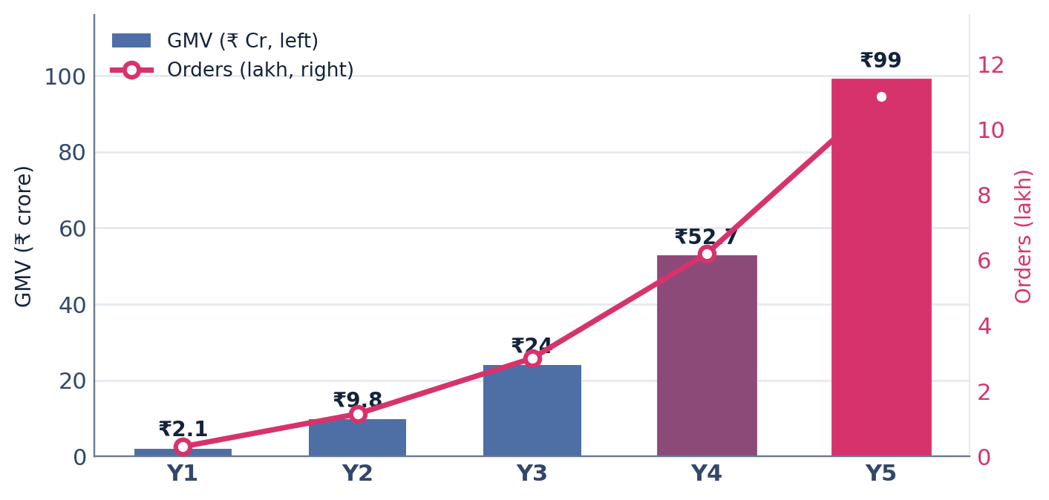
Figure 3 — GMV (bars) and order volume (line) across the five-year plan.

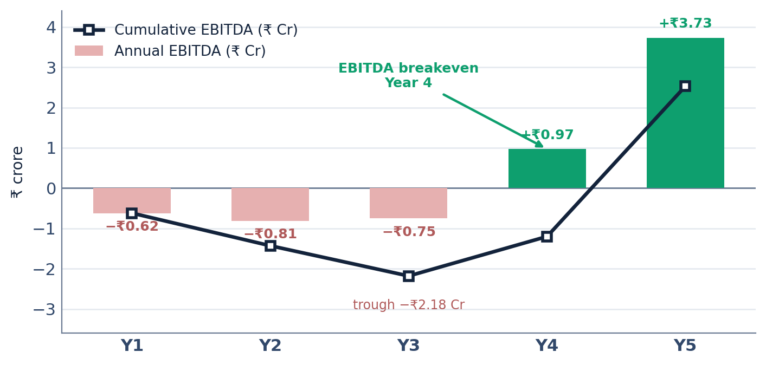
Figure 4 — Path to EBITDA: annual bars, cumulative line, breakeven in Year 4.

The assumptions that drive it
- Cities & stores: 1 → 11 cities (Indore first); ~100 stores per city, 100 → 1,100 total.
- Orders & AOV: 30k → 1.1M orders/year; AOV ₹700 → ₹900.
- Commission: 20% → 18% blended, on full pre-discount order value.
- Discount absorption: 12% → 4% of GMV, fully Trendzo-funded.
- Delivery fleet: salaried agents ₹15k/mo + ₹2.5/km fuel (~₹15/order in Year 1); cost per order falls as agents fill capacity.
- Retention: repeat rate ~35% → ~50%; frequency 2.5 → 4 orders/year; payment processing 2% of collected value.
Path to profitability: contribution-positive from Year 2, EBITDA breakeven in Year 4, ~18% margin and +₹3.73 crore EBITDA by Year 5, on a peak cumulative burn of −₹2.18 crore at Year 3.
What it means. The single load-bearing assumption is the ₹900 Year-5 AOV — above grocery quick-commerce norms, defensible for fashion baskets. If AOV holds nearer ₹700, contribution compresses; the Appendix sensitivities show the swing.

10 The Ask
₹2 crore takes Trendzo to a Year-1 proof in Indore — offered two ways, so an investor can choose certainty of capital or a lighter, milestone-phased entry.
Amount & instrument. Raising ₹2 crore as a pre-seed on a priced equity round (or SAFE). The same total is available in two structures:
 | Option A — single tranche | Option B — phased
Capital | ₹2 crore, up front | ₹50 lakh now + ₹1.5 crore at end of Year 1
Valuation | ~₹9 Cr pre / ₹11 Cr post | ~₹11.3 Cr pre / ₹13.3 Cr post
Founder dilution | 18% | 15%
What it asks of the investor | Full ₹2 Cr committed at close | ₹1.5 Cr released on Year-1 proof
Table 4 — Two structures for the same ₹2 crore raise.
Both raise the same ₹2 crore to the same Year-1 milestone. Option A prices the certainty of full capital up front — more equity for more risk. Option B rewards the company for de-risking the investor: the ₹1.5 crore is released only on hitting the Year-1 proof below, so the round prices three points tighter. In the phased case the ₹50 lakh funds the build and Indore soft-launch; the ₹1.5 crore, at the end of Year 1, scales the proven model into Year 2.
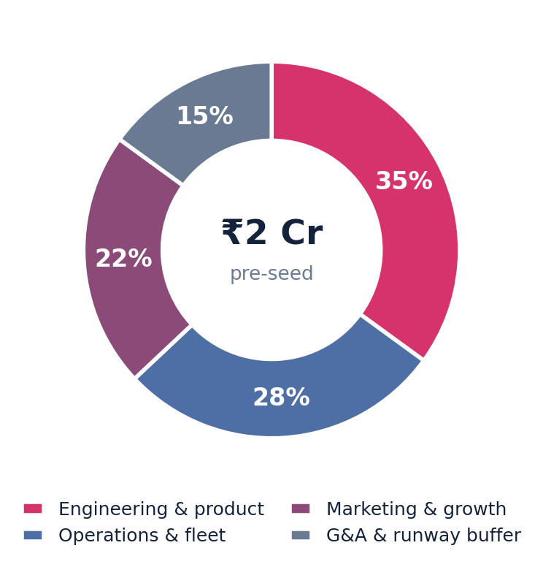
Figure 5 — Use of funds across the full ₹2 crore (either structure).
Across the raise, each bucket is tied to a milestone:
- Engineering & product (35%) → retailer/admin dashboard and agent app live; routing and COD reconciliation in production. (Phase-1 priority.)
- Operations & fleet (28%) → ~100 Indore stores onboarded onto live inventory sync; three-agent fleet operating; sub-60-minute delivery proven.
- Marketing & growth (22%) → a ~150-orders/day exit run-rate in Indore, with first repeat-rate cohort data. (Phase-2 weighted.)
- G&A & runway buffer (15%) → compliance, legal, and working-capital cushion through the build.
What it positions us for. Either structure reaches the same Year-1 proof, then a ₹2–3 crore seed (~Month 18) bridges the −₹2.18 crore trough and funds expansion to four cities — en route to a Year-4 EBITDA breakeven.
What it means. Either way the company raises ₹2 crore to a Year-1 proof. Option A trades three points of equity for certainty of capital; Option B trades a contingent second tranche for a higher valuation. Both buy a working one-city engine and the cohort evidence that turns the seed into a scale-up decision, not another proof-of-concept.

Appendix Model, Assumptions & Sensitivities
The full proof behind the brief — the complete five-year P&L, the driver log, sensitivities, and market-sizing sources.

A.1 Full five-year P&L (₹ lakh)
₹ lakh | Y1 | Y2 | Y3 | Y4 | Y5
Commission | 42.0 | 195.0 | 456.0 | 1,001.3 | 1,782.0
Delivery fees | 3.5 | 17.7 | 43.7 | 93.5 | 172.6
Ads (Y3+) | 0.0 | 0.0 | 9.0 | 40.3 | 115.5
Net revenue | 45.5 | 212.7 | 508.7 | 1,135.1 | 2,070.1
− Discount absorbed | 25.2 | 87.8 | 168.0 | 263.5 | 396.0
− Payment processing | 3.7 | 17.8 | 44.6 | 100.1 | 190.1
− Delivery fleet cost | 17.1 | 66.3 | 138.6 | 264.0 | 436.8
Contribution | (0.5) | 40.9 | 157.5 | 507.5 | 1,047.3
− Overhead (fixed) | 61.2 | 121.8 | 232.5 | 410.1 | 673.8
EBITDA | (61.7) | (80.9) | (75.0) | 97.4 | 373.5
Table A1 — Full P&L (₹ lakh). Parentheses negative. 1 crore = 100 lakh.

A.2 Driver log
Driver | Y1 | Y2 | Y3 | Y4 | Y5
Cities | 1 | 2 | 4 | 7 | 11
Stores on platform | 100 | 200 | 400 | 700 | 1,100
Orders / year | 30k | 1.3 L | 3.0 L | 6.2 L | 11.0 L
AOV (₹) | 700 | 750 | 800 | 850 | 900
Commission rate | 20% | 20% | 19% | 19% | 18%
Discount (% of GMV) | 12% | 9% | 7% | 5% | 4%
Delivery agents | 7 | 26 | 52 | 95 | 151
Contribution / order (₹) | (2) | +32 | +53 | +82 | +95
Table A2 — Operating drivers behind the model.

A.3 Sensitivities & key risks
- AOV. The most load-bearing lever — Year-5 AOV near ₹700 (vs ₹900) compresses contribution materially, since delivery fees barely cover the fleet and commission carries the model.
- Fleet cost. Agents are modelled at ₹15k/mo + ₹2.5/km; if retention forces higher pay, contribution per order slips and breakeven moves out.
- Density. At ~100 stores/city against flat orders, per-store throughput is ~2–3 orders/day; the retailer value proposition strengthens as density rises.
- Conservative case. At 0.65× volume against a fixed cost base, the plan only just breaks even in Year 5 and does not recoup cumulative losses within five years — a real downside.

A.4 Market-sizing methodology & sources
TAM — India fashion & apparel retail ~₹9.6 lakh crore (industry estimate). SAM — India online fashion ~₹1.83 lakh crore (industry/Statista). SOM — bottom-up Year-5 GMV ₹99 crore. Quick-commerce context: India q-commerce GMV ~₹0.6 lakh crore FY25 → ~₹2.9 lakh crore 2030; q-commerce AOV ~₹500, Blinkit ₹625–709. Figures are estimates compiled from public industry sources for sizing only.
Currency note. All figures in Indian rupees. 1 crore = ₹10,000,000; 1 lakh = ₹100,000. Market figures are converted from US-dollar industry sources at ₹83 to the dollar. The model is reconciled — every line ties from order value to EBITDA.

Trendzo · Investor Brief · June 2026 · v1.0 · Strictly private & confidential

